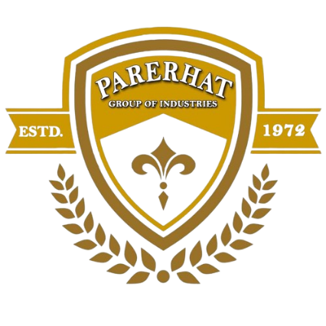

**Company Profile**

**Parerhat Chemicals Private Limited.**

### ****Company Overview****

Parerhat Chemicals Pvt. Limited is a part of the **Parerhat Group of Companies**, a diversified industrial powerhouse engaged in the manufacturing of **Medical & Industrial Gases, Aggregates, and Silica Sand**. Our commitment to excellence, cutting-edge technology, and customer satisfaction has established us as a trusted name in the industry.

With world-class Machinery**Metso 250 TPH Crusher Plants for**, advanced quality control laboratories, and a highly skilled workforce, we deliver **premium-quality products** that meet national and international standards.

**Company Details**

* **Company Name:**Parerhat Chemicals Private Limited
* **Registered Office:** 40, Industrial Colony, Daud Nagar, Naini, Prayagraj – 211008
* **GST Number:** 09AABCP4694H1Z2

**Our Group of Companies**

As a part of a diversified industrial group, Parerhat Chemicals Pvt. Ltd. operates in multiple sectors, ensuring top-notch quality and innovation in our product lines.

## **Our Products & Manufacturing Facilities**

### ****1. Medical & Industrial Gases****

We specialize in the production of **high-purity medical and industrial gases**, catering to healthcare, welding, food processing, and other industrial applications.

#### ****Our Gas Products:****

* **Oxygen (O₂):**Oxygen cylinders are widely used in medical, industrial, aviation, underwater, and emergency applications. In healthcare, they provide life-saving oxygen therapy for patients with respiratory conditions and during surgeries. Industries use oxygen in welding, metal production, and chemical manufacturing. In aviation and space travel, oxygen cylinders supply breathable air for pilots, astronauts, and high-altitude flights. Scuba divers and submarines rely on oxygen for underwater breathing, while firefighters and rescue teams use them in smoke-filled or hazardous environments. These versatile cylinders play a crucial role in sustaining life and enabling various critical operations.

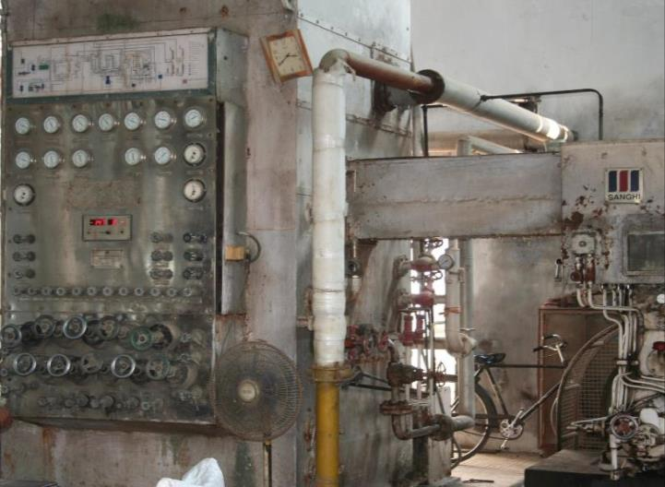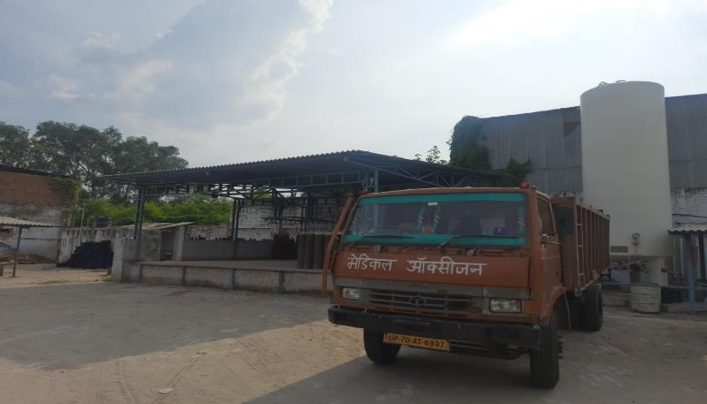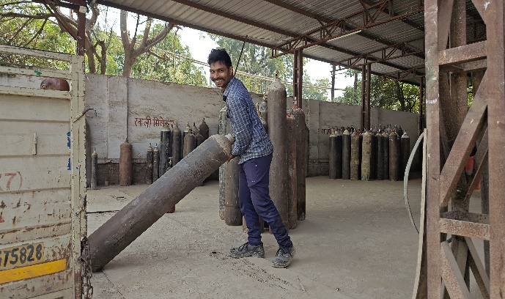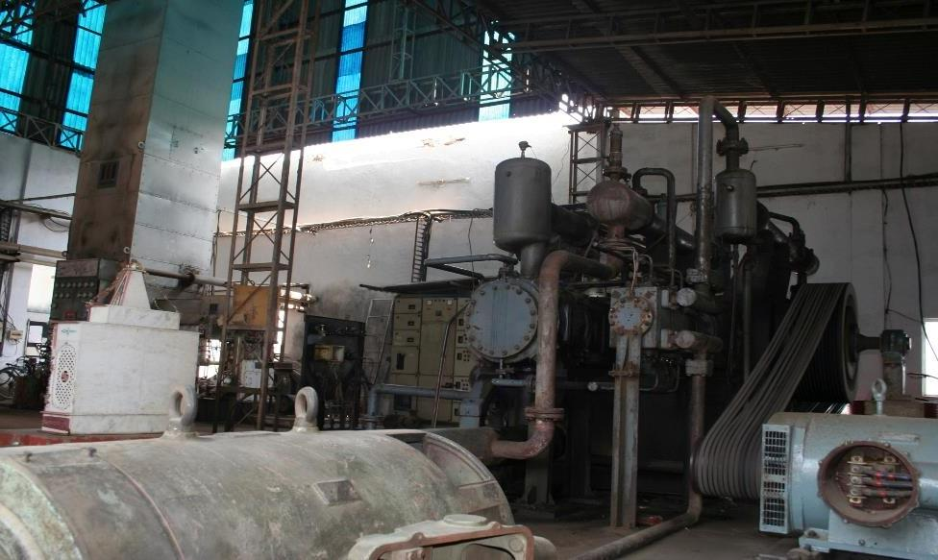

* **Nitrous Oxide (N₂O):**Nitrous oxide (N₂O), also known as laughing gas, is widely used in medicine, industry, and automotive applications. In healthcare, it serves as a mild anesthetic and pain reliever, commonly used in dentistry and childbirth. Industrially, it is utilized as a propellant in food packaging, particularly in whipped cream dispensers. In motorsports, nitrous oxide enhances engine performance by providing extra oxygen for combustion, boosting speed and power. Additionally, it has recreational use due to its short-lived euphoric effects, though misuse can pose health risks.

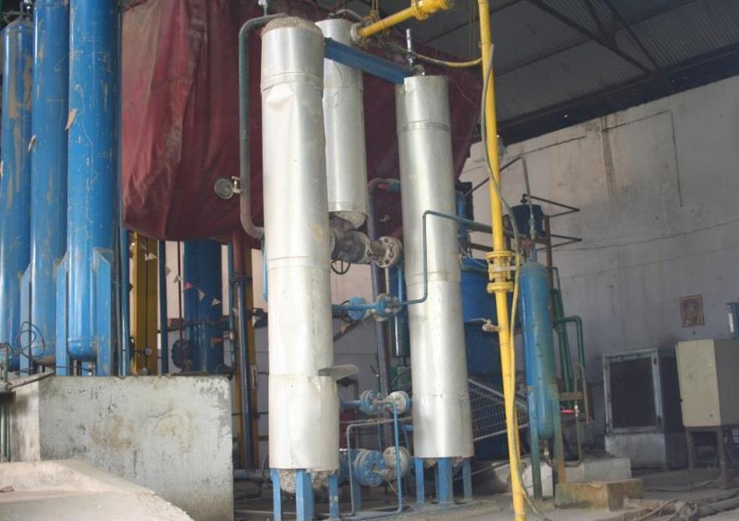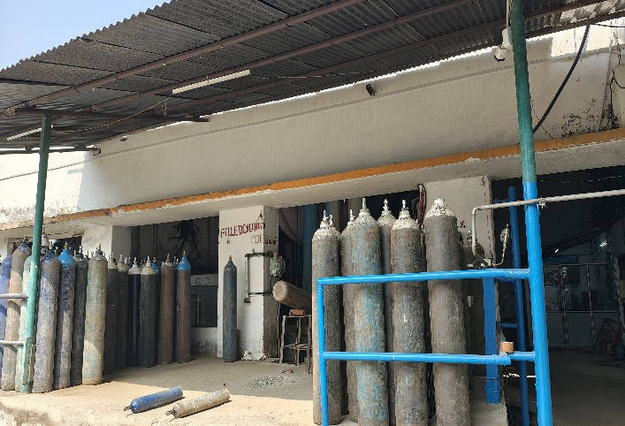

* **Acetylene (C₂H₂):**Acetylene gas (C₂H₂) is primarily used in welding, cutting, and metal fabrication due to its high flame temperature when combined with oxygen. It is essential in oxy-acetylene welding and cutting, making it ideal for industrial and construction applications. Acetylene is also used in chemical synthesis for producing plastics, synthetic rubber, and other organic compounds. In the glass and electronics industries, it is used for carbon coating and metal surface hardening. Additionally, acetylene lamps were historically used in mining and maritime navigation due to their bright and steady flame.

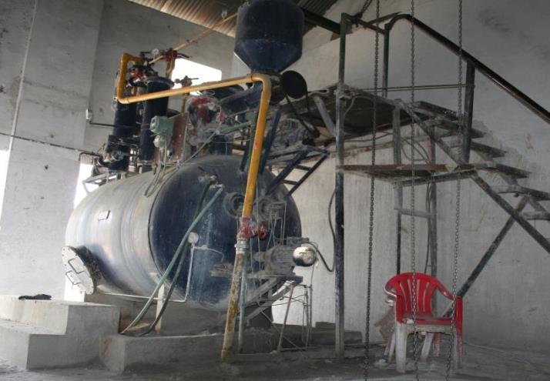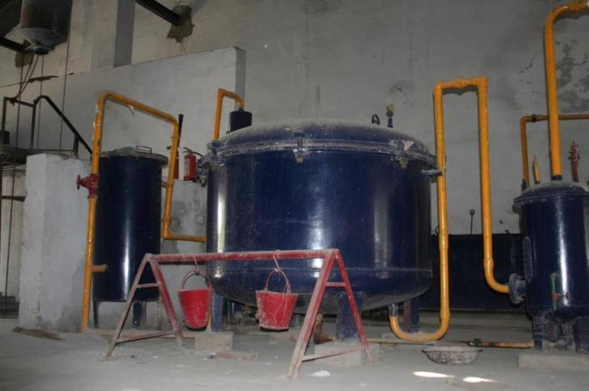

* **Carbon Dioxide (CO₂):** Essential for food & beverage processing, welding, and fire suppression.
* **Argon (Ar):** Commonly used in welding, electronics, and metal fabrication.

#### ****Manufacturing Facility:****

* Our **Sanghi Oxygen Plant**, known for its efficiency and superior quality, is located in **Naini, Prayagraj**.
* We follow **strict quality control measures** to ensure purity and safety.

### ****2. Aggregates Manufacturing****

Our aggregates are widely used in **construction, road building, railway projects, and infrastructure development**. We ensure uniform quality, strength, and durability in every batch.

#### ****Our Aggregate Products:****

* **G2, G3, GSB:** Essential materials for road construction and foundation works.
* **10mm Aggregate:** Ideal for concrete mix and block manufacturing.
* **20mm Aggregate:** Used in reinforced cement concrete (RCC), pavement layers, and drainage applications.

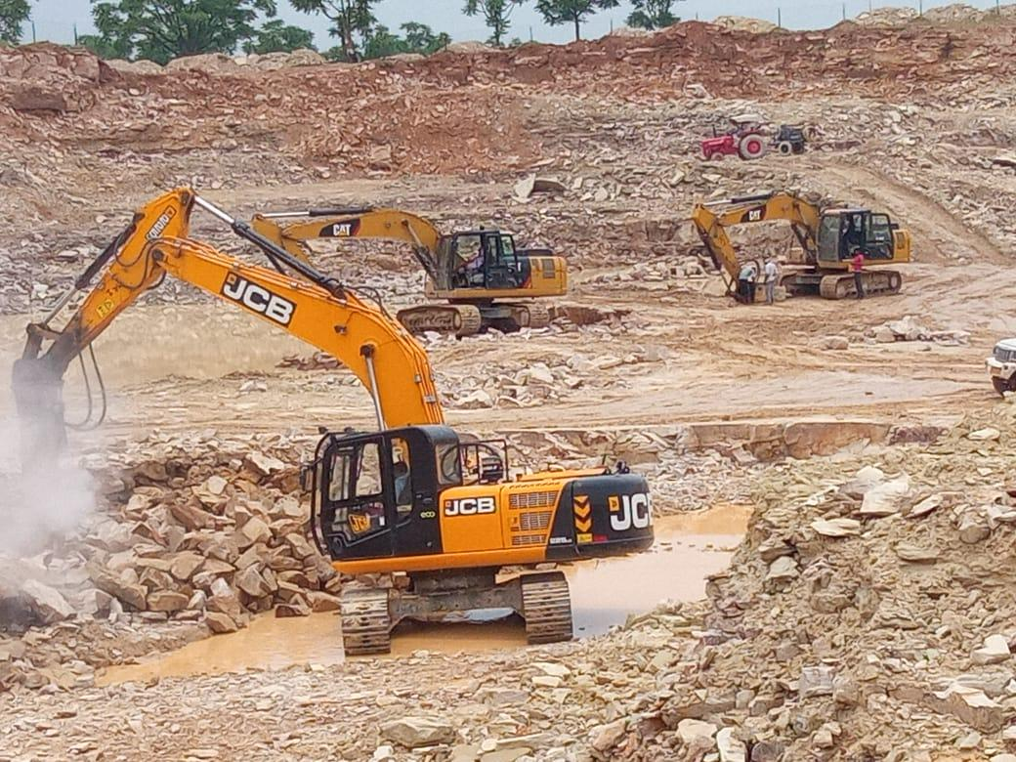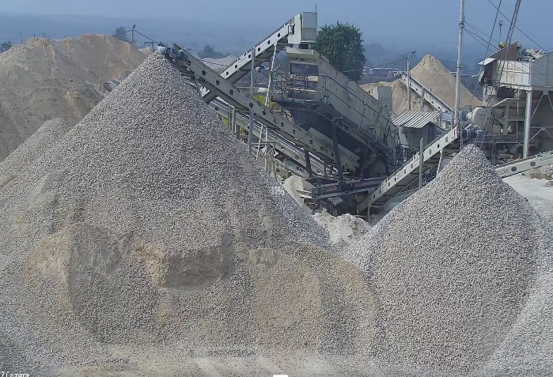

#### ****Manufacturing Facility:****

* We use the **Metso 250 TPH crusher Plant**, one of the most advanced aggregate production plants.
* Our aggregates are rigorously tested to ensure compliance with construction industry standards.
* **Location:Kodharghat, MejaPrayagraj.**

### ****3. Silica Sand Manufacturing****

Silica sand is a **high-demand material** used in **glass production, foundries, filtration systems, ceramics, and construction**. We provide **high-purity silica sand** with controlled grain size and consistency.

#### ****Key Features of Our Silica Sand:****

* **High Purity & Low Impurities:** Ensuring superior performance in industrial applications.
* **Uniform Grain Size:** Suitable for glassmaking, foundry casting, and filtration.
* **Quality-Assured Production:** Each batch is tested in our **in-house laboratory** for optimal performance.

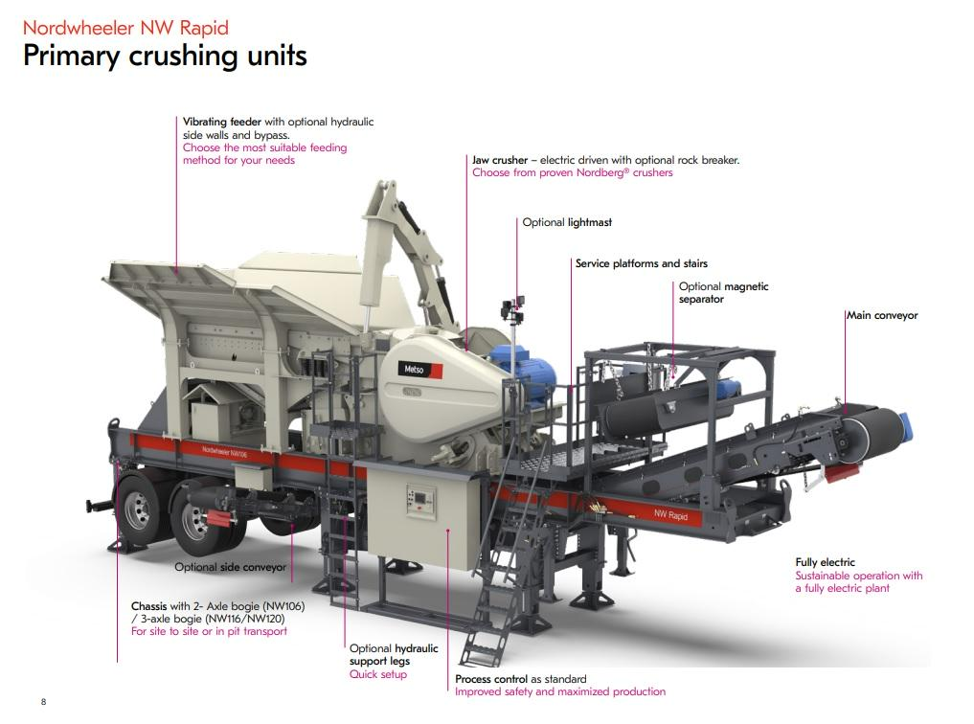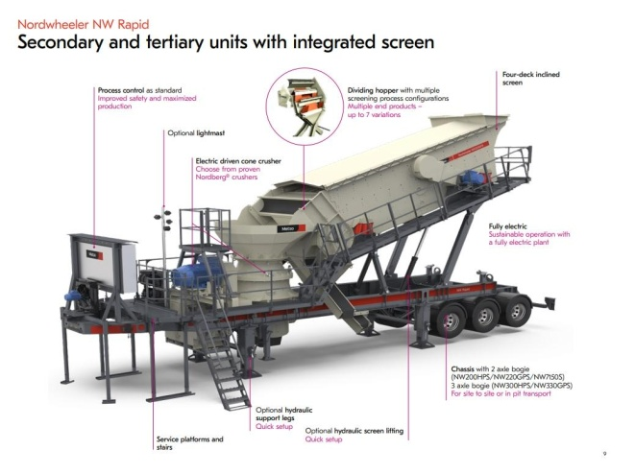

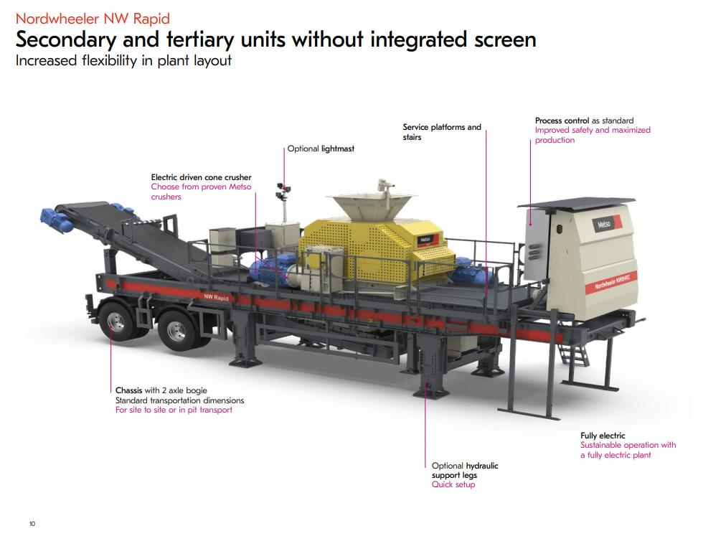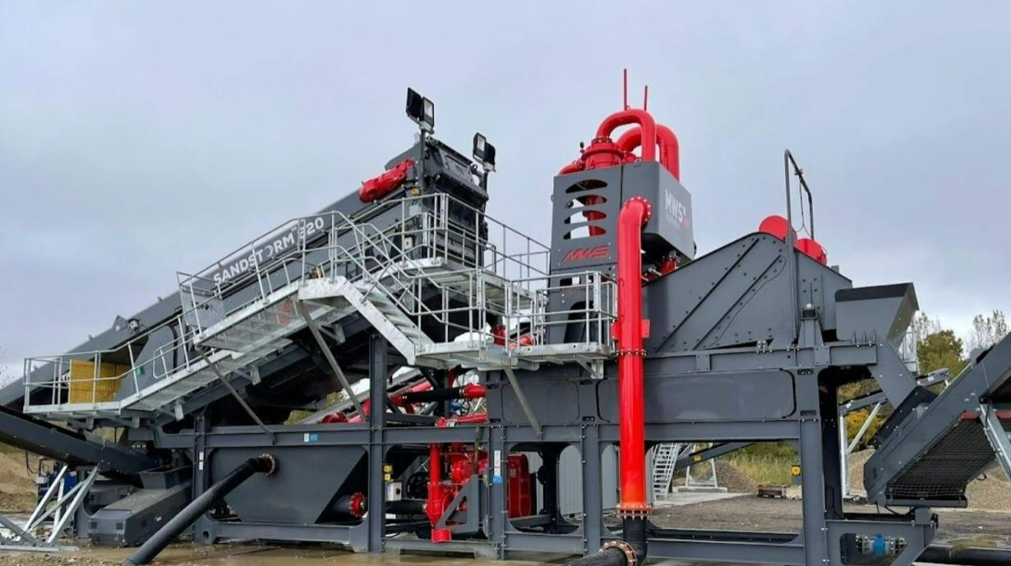

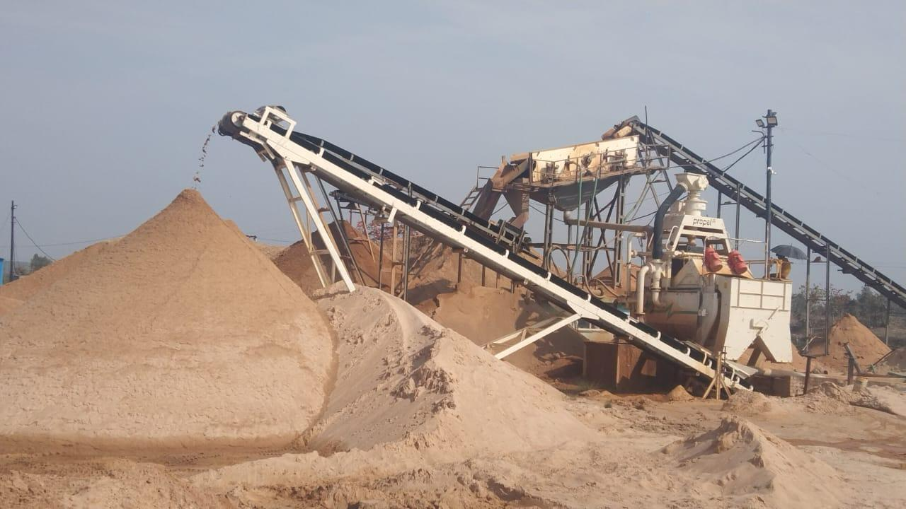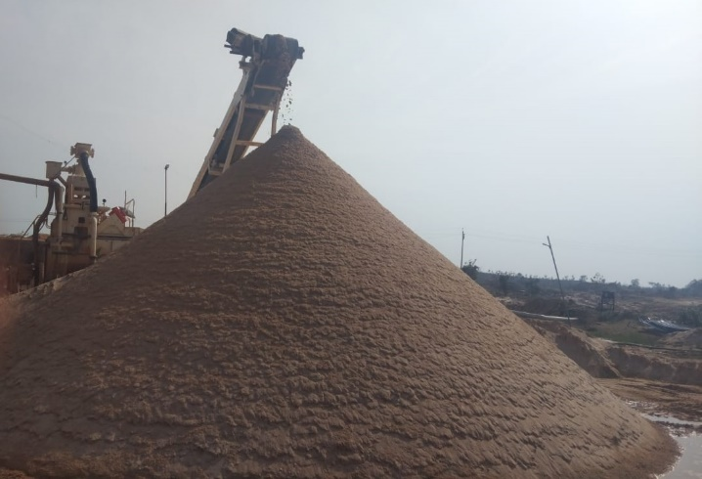

#### ****Manufacturing Facility:****

* Our **Metso 250 TPH crusher Plant**, dedicated to silica sand production, ensures **consistency and quality**.
* We follow **strict quality control processes**, making our silica sand one of the best in India.
* **Location:Pure BalduShankergarhPrayagraj.**

**Our Financial Performance Overview**

**(Gas Division)**

#### ****EBITDA and Profit/Loss (2012-2024)****

The company has demonstrated significant growth in its financial performance:

* **EBITDA** peaked at **INR 136.6 Lacs** in 2022, reflecting efficient operations.
* **Profit/Loss** showed resilience, with a peak of **INR 18.75 Lacs** in 2023, despite market fluctuations.
* Consistent recovery from losses in earlier years (e.g., 2017: -INR 1.31 Lacs).

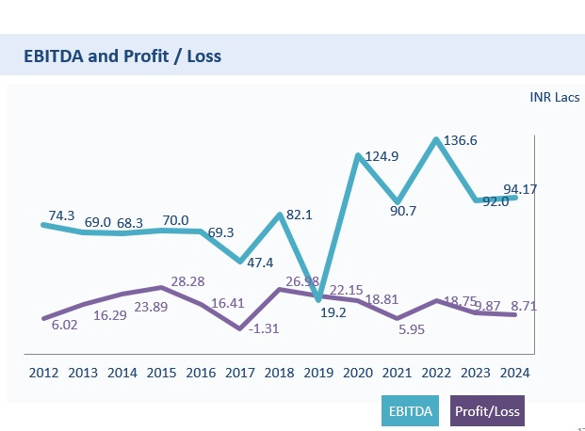

### ****Debt Management****

#### ****Interest Paid (Gas Division)****

* The company’s interest payments for **CC** and **Term Loan** have seen a sharp decline.
* By 2024, the Term Loan interest is fully eliminated, reflecting effective repayment strategies.

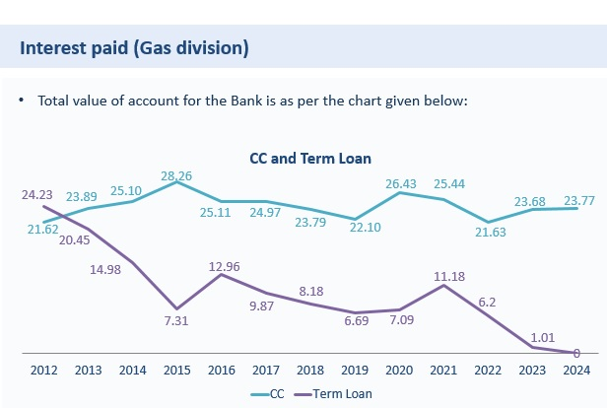

#### ****Term Loan Details****

* As of 2024, Parerhat Chemicals is **completely debt-free**.
* The only outstanding liability is a small vehicle loan of **INR 10.50 Lacs**.
* A significant portion of cash accruals has been reinvested back into the business, showcasing the company’s focus on long-term sustainability.

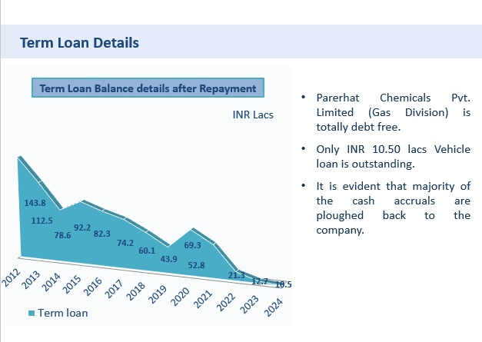

### ****Turnover Trends (2012-2024)****

The company’s turnover trends highlight steady growth and stability:

* Turnover peaked at **INR 11.05 Lacs** in 2022.
* Despite minor fluctuations, the overall trend reflects consistent performance.

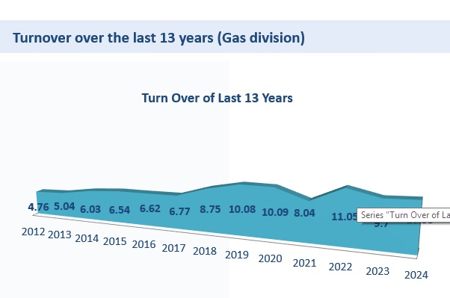

### ****Conclusion****

Parerhat Chemicals Private Limited (Gas Division) continues to set benchmarks in operational excellence and financial sustainability. The company’s focus on debt management, reinvestment of cash accruals, and steady turnover growth positions it as a leader in the chemical industry.

**(Mining Division)**

### ****Our Financial Performance Overview****

#### ****1. EBITDA & Profit/Loss (2021-2024)****

Over the last four years, the EBITDA and profit/loss of our mining division have shown steady performance.

* **EBITDA Growth:** The EBITDA has fluctuated between **₹2.4 lacs in 2021** to **₹2.99 lacs in 2024**, demonstrating stable operational efficiency.
* **Profitability:** Despite industry challenges, the division has maintained a consistent profit, with a peak of **₹0.5 lacs in 2022** and **₹0.19 lacs in 2024**.

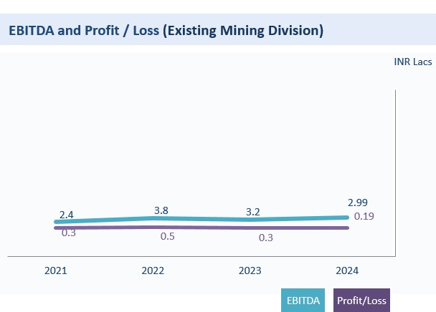

#### ****2. Term Loan Repayment****

Our disciplined financial management has significantly reduced the term loan:

* From **₹5.8 Cr in 2021**, we have successfully brought it down to **₹2.9 Cr in 2024**.
* The outstanding bank loan, which initially stood at **₹582 lacs**, has now reduced to **₹295 lacs**, showcasing our commitment to financial sustainability.
* Most of the cash accruals have been reinvested into the company for growth and stability.

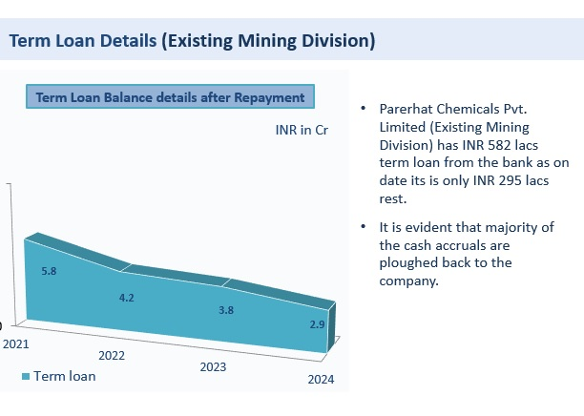

#### ****3. Turnover Trends (2021-2024)****

The turnover for the mining division reflects market dynamics:

* It peaked at **₹23.36 Cr in 2022** before stabilizing at **₹20.05 Cr in 2024**.
* The fluctuations indicate the industry’s cyclical nature while maintaining strong revenue generation.

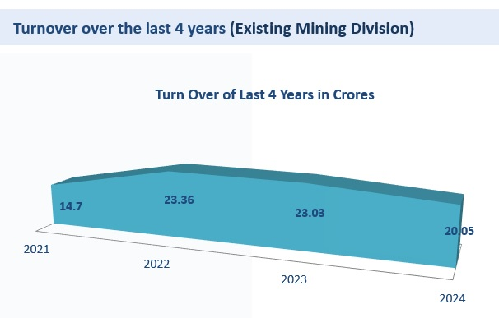

### ****Conclusion****

The mining division of **Parerhat Chemicals Private Limited** has exhibited consistent financial discipline, reducing liabilities while sustaining revenue and profit growth. The strategic reinvestment of cash accruals into operations ensures long-term financial strength and stability.

## **Why Choose Parerhat Chemicals Pvt. Limited?**

**State-of-the-Art Manufacturing Facilities** (Metso 250 TPH Crusher Plants)  
**Unmatched Product Quality &Consisteny**  
**Dedicated In-House Quality Control Laboratory**  
**Industry-Leading Customer Satisfaction & Reliability**  
**Trusted by Clients Across India**

## **Company Details**

📌**GST No.:** 09AABCP4694H1Z2  
📍**Manufacturing Locations:**

* **Medical & Industrial Gases:**Naini, Prayagraj
* **Aggregates:Kodharghat, MejaPrayagraj.**
* **Silica Sand : Pure Baldu, ShankergarhPrayagraj.**

📧**Email:** info@parerhat.in  
📞**Contact:** +91 9415215973  
🌐**Website:**[www.parerhat.com](http://www.parerhat.com)